Optimizing Furnace Spalling in Delayed Coking Units: A Data-Driven Approach
Prepared by:
Akash Anand, Senior Manager – Process Technologies
Kaushal Sampat, Director of Digitalization
Steve Beeston, Refinery Digitalization Consultant, DCU SME
Published: January 2026

Abstract
Furnace tube fouling due to coke deposition is a critical operational challenge in delayed coking units (DCUs), directly impacting heat transfer efficiency, throughput, and heater run length. Spalling is widely employed as an online decoking technique; however, its effectiveness can vary significantly depending on operating practices.
This paper presents a data-driven analysis of spalling operations for a North American DCU across multiple furnace passes over an extended operating period. Key performance indicators (KPIs) were established to quantify spall effectiveness, and correlations between operational parameters and outcomes were developed. This study identifies critical thresholds, best practices, and decision rules that can significantly improve spall efficiency, reduce operational variability, and enhance furnace performance.

1. Introduction

Delayed coking is a thermal cracking process employed to upgrade heavy residual fractions into lighter hydrocarbons and petroleum coke. The performance of the furnace is a key determinant of unit performance and throughput. Progressive coke deposition within the furnace tubes during operation degrades heat transfer, increases tube side pressure drop, and constrains feed processing capacity.
Spalling is an online decoking method employed to remove coke deposits without requiring a unit shutdown. Its effectiveness is dependent on factors such as temperature control, spall duration, and fouling severity. The spalling process involves shifting the furnace from normal operation to a spalling regime by replacing the hydrocarbon feed with steam and/or water, while sustaining elevated COT (Coil Outlet Temperature) and controlled TMT (Tube Metal Temperature). Under these conditions, high-velocity flow, turbulence, and thermal shock generate mechanical stresses and differential expansion between the coke layer and tube metal, leading to coke cracking and dislodgement.
The extent of coke removal is reflected by a reduction in CIP (Coil Inlet Pressure) and a decrease in the TMT-COT differential. TMT is continuously monitored to ensure tube integrity. Upon completion of the spall, the furnace is transitioned back to normal operating conditions.
This study analyzes historical spall data to:
- Quantify spall effectiveness using objective metrics
- Identify key drivers of successful spalling
- Develop operational guidelines for consistent spalling performance

2. Methodology

2.1 Data Overview
The analysis is based on an extensive dataset covering multiple furnace passes and operating cycles of a North American DCU. Each spall event was evaluated using both during-spall and post-spall performance indicators.

2.2 Key Performance Metrics
2.2.1 Post-Spall Effectiveness Index
This metric assesses furnace condition following spall using normalized performance indicators. Recovered TMTs alone do not give a complete picture of spall effectiveness, as they are significantly influenced by variations in operating conditions such as feed rate, flow distribution, CIT, COT, coil pressure drop, etc. Therefore, normalization against appropriate reference conditions is necessary to determine the real effectiveness of the spall.
A Post-Spall Effectiveness Index was derived to measure the effectiveness of a spall. It is based on the following indicators:
- Gap of actual TMT to reference clean TMT at start of the run
- Normalized CIP per unit feed at start of the run
- COT at start of the run
Higher values of this index indicate a more effective coke removal and improved furnace tube cleanliness, while lower values indicate residual fouling.
2.2.2 Online Spall Effectiveness
It is possible to measure spalling effectiveness in real-time during a spall. Again, a dimensionless index was developed to indicate how the spall is progressing. This online spall effectiveness index uses multiple inputs (temperatures, flows, pressures, etc.) referenced to an established baseline. This index is monitored during the spalling operation to determine the real-time effectiveness of the spall throughout the furnace coil and identifies the need for any corrective actions to improve the spall in progress.

3. Results and Discussion

3.1 Key Drivers for Successful Spalling
3.1.1 Effect of Total Spall Duration
Many spalling procedures define a time duration for the spalling operation. While this time can result in effective spalls, total time spent spalling is not necessarily a good indicator of an effective spall as shown below.
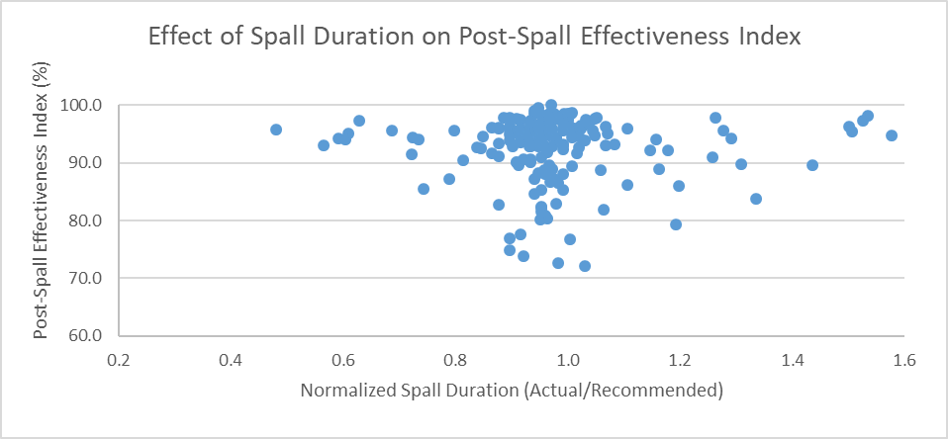
Figure 1: Effect of Total Spall Duration

The actual execution of the spall has a larger impact on the effectiveness of the spall than duration alone. TMTs and tube shocking also play an important role as discussed below.
3.1.2 Effect of TMT hold duration Above the Threshold TMT
Spall effectiveness is highly dependent on maintaining elevated TMTs. Data analysis showed that there is a threshold TMT for effective spalling and TMTs must be held above this threshold temperature for a sufficient period of time. The hold duration above this threshold TMT is defined as the fraction of total spall time during which TMTs remain above this threshold. The threshold TMT varies depending on furnace design and tube metallurgy.
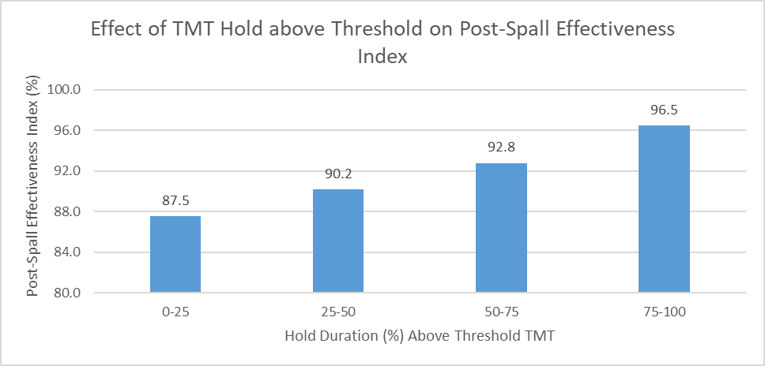
Figure 2: Effect of TMT Hold Duration on Spall Effectiveness
Spall effectiveness increases sharply beyond ~75% hold duration, indicating a threshold-driven response. Shorter hold durations (<50–75%) result in incomplete coke removal despite other efforts.

3.1.3 Role of Tube Shocking
Tube shocking is a spalling technique in which the coil temperature is rapidly reduced and then quickly restored to create contraction and expansion of the tubes to dislodge the coke in the tubes. This shocking process can be carried out multiple times during the spall to aid the coke removal from the furnace tubes.
The effectiveness of tube shocking is dependent upon the intensity of the shock. Shock intensity can be measured by the magnitude of TMT reduction per unit time. High shock intensity indicates quick TMT reduction and restoration in less time. Shock intensity percentages are calculated based on the maximum shock intensity attainable, which is set by tube metallurgy and furnace design.
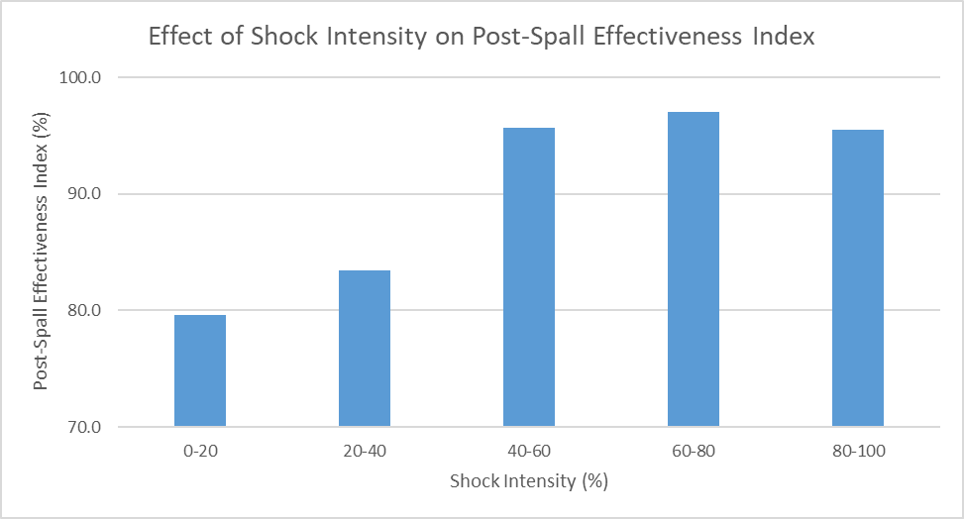
Figure 3: Effect of Tube Shocking on Spall Effectiveness
High shock intensity significantly enhances coke removal due to stronger thermal differentials between the coke and tube metal.
A threshold behavior is evident with spall effectiveness improving significantly above 40% of maximum shock intensity. Low-intensity shocks cause inefficient coke layer removal.

3.1.4 Online Spall Effectiveness
The ability to measure spall effectiveness in real-time during a spall can greatly improve the effectiveness of the spall. Monitoring the online spall effectiveness factor helps determine the need for tube shocking and the overall duration of the spall.
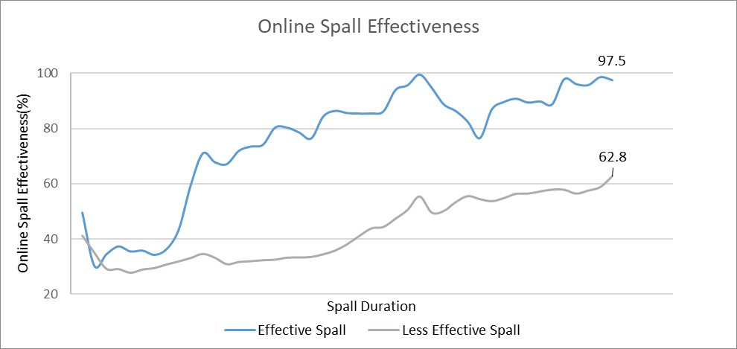
Figure 4: Online Spall Effectiveness during Spall

3.2 Impact of Effective Spalling On DCU Operations
Effective spalling is the key to increased operational performance of DCUs.
3.2.1 Impact on Post Spall Throughput
Effective spalling directly translates into measurable throughput improvement of 5-10%. Cleaner tubes restore heat transfer efficiency, enabling higher feed rates and extended run lengths.
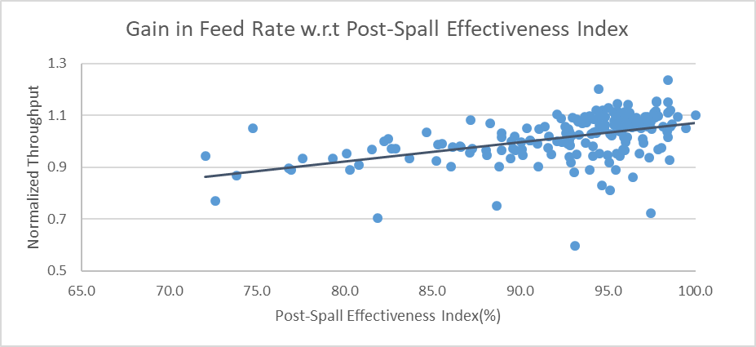
Figure 5: Gain in Throughput after Effective Spall
3.2.2 Impact on Coil Inlet Pressure
A large reduction in normalized CIP confirms successful coke removal and reduced flow resistance.
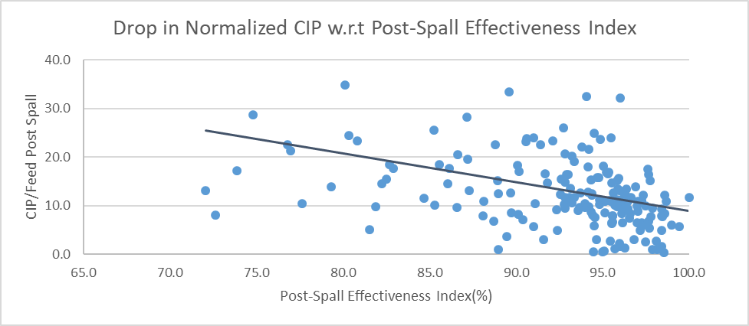
Figure 6: Reduction in Normalized CIP after Effective Spall
Less effective spalls (spalls with a lower Post-Spall Effectiveness Index) maintain a higher CIP, signaling residual fouling.

3.2.3 Impact on Tube Metal Temperature
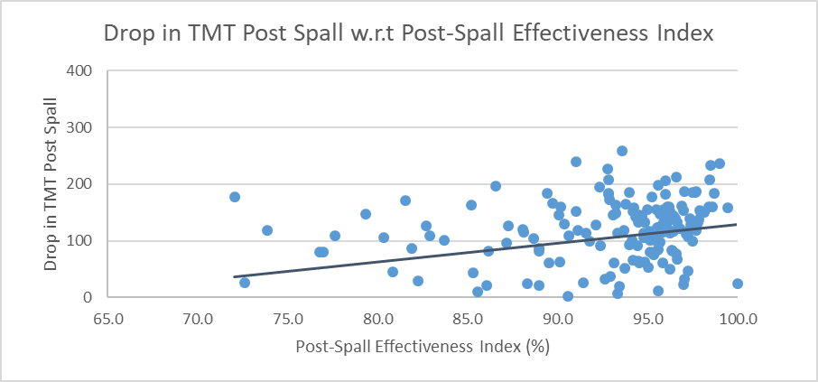
Figure 7: Drop in TMT value after Effective Spall
As expected, post-spall TMT decreases due to improved heat transfer from cleaner tube surfaces. While this can be an indicator of furnace cleanliness improvement and spall efficiency, it does not provide a complete picture as other factors influence post-spall operation.

4. Real-Time Spall Effectiveness Monitoring and Decision Support
The post-spall and online spall effectiveness indices, implemented as KPIs within the DCU operating dashboard, provide both real-time monitoring and post-analysis capabilities to improve spalling performance. These indices enable operators to track spall progression, adjust operating parameters dynamically, identify the need for tube shocking, and determine optimal termination timing. Field application across multiple DCUs has consistently demonstrated enhanced spalling effectiveness, with Ingenero’s monitoring models reducing average spall duration by approximately 3–4 hours, leading to improved operational efficiency and overall profitability. To illustrate the implementation approach, a representative mock-up of the spall monitoring screen is shown. The displayed screen is indicative; actual values and configurations will vary according to individual DCUs and owner requirement.
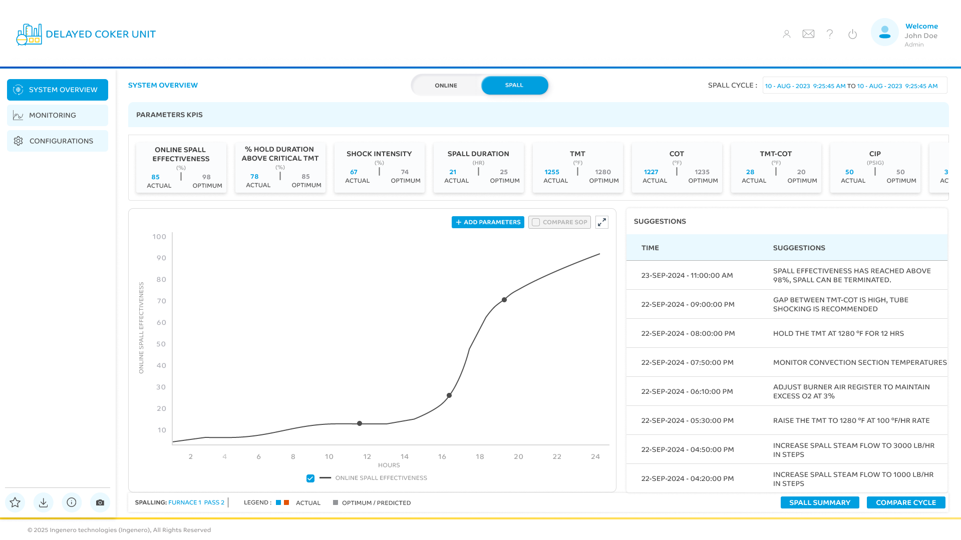
Figure 8: Delayed Coker Unit Spall Screen (Sample)

5. Summary
- Spall duration alone is not a key driver; extending duration beyond optimal provides minimal additional benefit.
- A 3-4 hour reduction in average spall time has been demonstrated in commercial operation for a number of DCUs using Ingenero’s Online Spall Effectiveness Index.
- Spall effectiveness is primarily driven by maintaining adequate TMT hold duration, with >75% hold duration above a threshold temperature yielding the best results.
- Tube shocking plays a critical role in high-fouling conditions, with effectiveness significantly improving with higher shock intensities.
- Effective spalling leads to measurable performance gains, including increased throughput, extended furnace run length, and improved furnace operability.

6. Conclusion
This study shows that spall effectiveness can be significantly enhanced through data-driven monitoring and control of key parameters. The Spall Effectiveness Indices provide normalized, real-time representations of coke removal from the furnace tubes. This enables consistent tracking and evaluation of spalls as well as real-time monitoring and objective decision-making during spall execution.
They help identify less effective spalls and provide a basis for improving spalling procedures, optimizing hold duration, and determining the appropriate spall duration. By standardizing practices such as tube shocking and avoiding spall extension, operators can improve furnace efficiency, extend run length, increase throughput, and reduce variability.

7. Ingenero, Inc.
Ingenero is an engineering company focused on solving process challenges since 2001. Headquartered in Houston, TX, today Ingenero provides project engineering, AI/ML and digitalization, and process safety engineering services. Ingenero has a vast amount of domain knowledge given the process, safety and mechanical engineers we employ came from industry and understand where the hidden value can be found.

